Brook Street School
PE & Sports Premium Funding – Archived years
Sports Funding Money Statement 2017-2018
We have continued to build upon the development of sports opportunities and participation this academic year. Our focus continues to be increased participation, improved opportunities for competitive sports and CPD for staff.
Below we have detailed what we have spent our sports funding money on and how it has had an impact on the children in our school.
Swimming
Start date: September 2017
End date – July 2018
Cost: £2600 (including travel)
In addition to the government’s requirements for children to learn to swim. Brook Street continue to provide an additional 2 year groups to attend swimming at The Pools Carlisle. Children from Year 1 and 2 attended swimming for 6 weeks per year group.
RRCA
Start date: September 2017
End date – July 2018
Cost: £650
We have spent £650 on the use of RRCA facilities including undertaking multi-skills activity mornings and additional sporting activities.
Football afterschool club
Start date: September 2017
End date – July 2018
Cost: £250
We have spent £250 on paying for 2 members of Brook Street staff to coach the school’s football team. Children receive coaching and training during an afterschool club. Children compete in local cluster competitions and also have competed in additional competitions.
Sands Centre Football Competition
Start date: January 2018
End date – January 2018
Cost: £50
We have spent £50 on entering 2 different football competitions which will be held at The Sands Centre. Children will compete against local schools within the competition.
Projected Spending of remaining Sports Premium
Year 6 Swimming
Start date: June 2018
End date – June/July 2018
Cost: Estimated cost: £850
This is to ensure that all children leave primary school with the ability to swim a minimum of 25m.
Additional P.E. Equipment
Start date: January 2018
End date – July 2018
Cost: Estimated cost: £1000
Development and replacement of equipment to maintain opportunities within lessons and after school clubs.
Sports Day
Start date: June 2018
End date – June/July 2018
Cost: Estimated cost: £250
Continuing with the success of last years sports day we aim to replicate this. Monies will be spent for hiring porta-loos, additional equipment and healthy refreshments for the children.
Outdoor Play Equipment
Start date: July 2018
End date –
Cost: Estimated cost: £500
We will purchase new play equipment for children to use during playtime and lunch times. Children from older years will be trained of how to use the equipment and how to encourage other children to use the equipment for different purposes e.g. creating new active games. There is a plan for next academic year to employ 2 playground leaders to develop sports at lunchtimes.
Fruit
Start date: January 2018
End date – June/July 2018
Cost: Estimated cost: £500
As a school we want to offer each child a piece of fruit or vegetable at break time each school day. Children will have a variety of different seasonal options which will be delivered fresh to school regularly.
Sports Funding Money Statement 2016-2017
At Brook Street School we have spent our sports money in a variety of ways. At the forefront of our planning was ensuring that every child received a better physical education as a result of the additional sports funding in school.
We have aimed to increase participation rates in our after school clubs, to become more successful at competitive sports within our schools cluster. To provide children with excellent physical education through the continual professional development for all our staff. To highlight the importance of physical education and its impact on; self- confidence, self -esteem, academic achievement and promote a life- long enjoyment of sport and exercise as well as an understanding of the health benefits to this.
Below we have detailed what we have spent our sports funding money on and how it has had an impact on the children in our school.
Swimming
Start date: September 2016
End date – July 2017
Cost: £2600 (including travel)
In addition to the government’s requirements for children to learn to swim. Brook Street provided an additional 2 year groups to attend swimming at The Pools Carlisle. Children from Year 1 and 2 attended swimming for 6 weeks per year group.
RRCA
Start date: September 2016
End date – July 2017
Cost: £650
We have spent £650 on the use of RRCA facilities including undertaking multi-skills activity mornings and additional sporting activities.
Football afterschool club
Start date: September 2016
End date – July 2017
Cost: £250
We have spent £250 on paying for 2 members of Brook Street staff to coach the school’s football team. Children receive coaching and training during an afterschool club. Children compete in local cluster competitions and also have competed in additional competitions.
Supply Cover for PE co-ordinator
Start Date: September 2016
Cost: £85
We spent £85 on supply cover so that our PE co-ordinator could attend the ACPEN meeting.
This course gave the PE co-ordinator information of how to develop P.E. in Brook Street School; curriculum, progression and also use of Sports Premium- use of Sports Premium for additional health reasons.
Sands Centre Football Competition
Start date: January 2017
End date – January 2017
Cost: £50
We have spent £50 on entering 2 different football competitions which will be held at The Sands Centre. Children will compete against local schools within the competition.
L1 Football Coaching
Start date: January 2017
End date – June/July 2017
Cost: £300 (£150 per person)
We have booked for the two members of staff who coach the football team to have accredited training. Staff will develop their knowledge of coaching football.
Projected Spending of remaining Sports Premium
Year 6 Swimming
Start date: June 2017
End date – June/July 2017
Cost: Estimated cost: £850
After SATs, children in year 6 will compete a block of swimming session held at The Pools. This is to ensure that all children leave primary school with the ability to swim a minimum of 25m.
Additional P.E. Equipment
Start date: January 2017
End date – July 2017
Cost: Estimated cost: £1000
We aim to purchase new netball posts which can also be used as basketball nets. These need to be easy to assemble which children can be trained to set up with adult supervision.
We aim to purchase new mats for gymnastic and floor based activities.

Sports Day
Start date: June 2017
End date – June/July 2017
Cost: Estimated cost: £250
Continuing with the success of last years sports day we aim to replicate this. Monies will be spent for hiring porta-loos, additional equipment and healthy refreshments for the children.
Planning- Progression
Start date: June 2017
End date – June/July 2017
Cost: Estimated cost: £340 + p&p
We will purchase the Cambridgeshire P.E. scheme of work. This scheme has been recommended within ACPEN meetings. The scheme of work clearly shows progression within many different sporting elements. Teachers are able to use the scheme as a full package, however teachers are able to adapt and change elements for their class.
Outdoor Play Equipment
Start date: January 2017
End date – June/July 2017
Cost: Estimated cost: £500
We will purchase new play equipment for children to use during playtime and lunch times. Children from older years will be trained of how to use the equipment and how to encourage other children to use the equipment for different purposes e.g. creating new active games.
Fruit
Start date: January 2017
End date – June/July 2017
Cost: Estimated cost: £500
As a school we want to offer each child a piece of fruit or vegetable at break time each school day. Children will have a variety of different seasonal options which will be delivered fresh to school regularly.
Sports Funding Money Statement 2015-2016
Swimming
Start date: September 2015
End date – July 2016
Cost: £2600 (including travel)
In addition to the government’s requirements for children to learn to swim. Brook Street provided an additional 2 year groups to attend swimming at The Pools Carlisle. Children from Year 1,2 and 3 attended swimming for 6 weeks per year group.
Evaluation and impact
As a result of children learning skills associated with swimming Years 1 and 2 will continue the swimming sessions during the academic year of 2016-2017 to further their skills within swimming.
RRCA
Start date: September 2015
End date – July 2016
Cost: £650
We have spent £650 on the use of RRCA facilities including undertaking multi-skills activity mornings. In addition to using the facilities RRCA sent a P.E. teacher to deliver gymnastics to children in Year 1.
Evaluation and impact
Children were able to develop their skills within different gymnastic areas are some children were ready to compete in a cluster schools gymnastic competition.
Football afterschool club
Start date: September 2015
End date – July 2016
Cost: £250
We have spent £250 on paying for 2 members of Brook Street staff to coach the school’s football team. Children receive coaching and training during an afterschool club. Children compete in local cluster competitions and also have competed in additional competitions.
Evaluation and impact
Children show interest and want to compete within cluster school sporting events. Children who attend the club gain additional teaching and experiences including sportsmanship.
We will continue this club in the new academic year.
Outdoor Environment
Start date: July 2016
End date – Completion date August 2016- Continued use of facility
Cost: £4000
We have spent £4000 on developing the outdoor provision. Although the size of the area has not increased the ability to complete sporting activities has been increased due to the removal of structures.
Evaluation
Children use the outdoor area to undertake a variety of activities including gross motor fitness activities. Children enjoy the outdoor area which is evident through their play and movement, furthermore children respect the outdoor environment.
Sports Day
Start date: July 2016
End date – July 2016
Cost: £200
We have spent £200 on our school Sports Day. In the past sports day has been undertaken on school grounds, however after discussion with varies stakeholders within the school the decision was made to have our sports day at Richard Rose Central Academy’s field. RRCA allowed Brook Street to use the facility for free however monies were spent on hiring porta-loos, water for throughout the day and fruit.
Evaluation
The day was a HUGE success. All children competed in a number of activities throughout the day including team sporting activities. Children were all engaged and enjoyed the competitive element of the day
Discussion with parents after the event commented on how much they had enjoyed watching their children race and compete in a different environment.
As a school we all enjoyed the day and would like to replicate the success of the day next year.
Sports Day- equipment
Start date: July 2016
End date – July 2016
Cost: £150
As continued from above- To undertake some different activities for sports day additional equipment was required. We purchased new athletics equipment for throwing for distance.
The new equipment has replaced some of the previous equipment within the school.
Evaluation
The new equipment has replaced some previous equipment that could not be used effectively. School will continue to develop skills needed for next year’s sports day and repeating the success this year’s sports day.
Premier Sport
Start date: September 2014
End date – July 2015
Cost: £4250
We have spent £4250 on sports coaching in school. We receive a full day of sports lessons for our FSU, year 1, year 2 and year 6 children. The children have been following the objectives set out in our PE long term plan for their year group. This has provided both quality teaching for our children and staff development opportunities for our teachers who have been present in all sessions.
As well as a whole day of sports coaching we have received 2 fencing clubs; one after school and one during lunch time.
Evaluation and impact completed on 04.12.14
We have found that the children in FSU, year 1, year 2 and year 6 have shown more enthusiasm in their PE lessons. We have attached some children’s responses and it is clear to see that the premier sport coaching has had a positive impact on their physical education.
Further evaluation and impact completed on: 16.07.15
In December 2014 we uploaded evidence of children’s enjoyment and this can be seen in addition to this document.
As a school we have taken the decision to invest in our staff knowledge and development and as a result we will not be paying for any premier sport coaching after July 2015. Although it did provide good coaching for the children at our school we believe that our staff have the capability to provide a physical education of an even higher quality. As a result of this decision we aim to provide opportunities for staff development and will be therefore spending our sports funding money in this way.
Sovereign Playground Markings
Start date: 19.03.15 and 09.04.15
Cost: £149.26 and £2,663.58
Total Cost of: £2812.84
We have paid £2812.84 to have our playground markings re designed and updated. We decided to have zones printed on top of our netball pitch to help when organising children during PE sessions. We updated all our markings to encourage children to continue their physical education at play and lunch times.
Evaluation and impact completed on 16.07.15
We have found that children are engaging with the markings during play and lunch times, particularly in key stage 1 where the children have been observed playing hopscotch as well as practising skills they have been taught during PE sessions. It has been noted by teachers that it is much easier to group children when teaching PE and attached is a testimonial from 2 teachers at our school. As a school we feel that the money has been well spent in this instance.
Vanessa Foster Gymnastics Professional Development
Start Date: 28.05.15
Cost: £400.00
We paid £400.00 for Vanessa Foster to provide 2 staff meetings about teaching gymnastics. She provided both theoretical and practical guidance to all teaching staff and left us with a variety of online support and guidance.
Evaluation and impact completed on: 16.07.15
Vanessa developed our staff knowledge and understanding of teaching gymnastics. The staff response to her training was positive and everyone left feeling excited to teach gymnastics with their class. (Attached are 2 staff testimonials.) As a school we feel this training was an excellent way to spend our sports funding money; it provided an investment in our staff which had an immediate impact upon gymnastics teaching, and it ensured quality gymnastics lessons for years to come. We will be continuing to up skill our staff in a variety of ways during the course of this academic year.

Football club
Dates – Continuing
Costs totalling £238.46 on 10.06.15 -(4 separate payments of: £67.53, £76.44 £50.24 and £44.25)
We continue to pay 2 members of staff to run our Monday night football club. This year we have just had our largest number of children (28) joining up for football club and we are hopeful that we will be successful within our cluster league this year.
Evaluation and impact completed on: 16.07.15
We have seen the highest numbers of children attending our football club and our branching out to have both a girls and boys team this year. We are currently entered into all the girls and boys competitions and are hopeful of success due to the good quality training the children are receiving. Attached are some photographs of our football club along with children’s views. As a school we plan to continue funding our football club using our own staff. We believe this provides value for money and is a sustainable way to spend our sports funding money.
Longhorn medals for sports day
Start date: 10.09.15
Cost: £450.00
We purchased bronze coloured medals with our school logo attached to give to competitors during sports day 2015. As Mrs Ditchburn was retiring we decided it would be nice for each child to be presented with a medal in commemoration of her time as head teacher.
Evaluation and impact completed on 19.09.15
All the children received a medal as part of our sports day and were pleased to get them. It is important that children link competition with reward and understand that when competing prizes can be won. As a school we feel that we honoured all competitors’ effort during sports day as well as providing additional prizes for 1st 2nd and 3rd places. We believe that this was a good way to spend our sports funding money.
Sports Funding Money Statement
2014 - 2015
At Brook Street School we have spent our sports money in a variety of ways. At
the forefront of our planning was ensuring that every child received a better
physical education as a result of the additional sports funding in school.
We have aimed to increase participation rates in our after school clubs, to
become more successful at competitive sports within our schools cluster. To
provide children with excellent physical education through the continual
professional development for all our staff. To highlight the importance of
physical education and its impact on; self- confidence, self -esteem, academic
achievement and promote a life- long enjoyment of sport and exercise as well
as an understanding of the health benefits to this.
Below we have detailed what we have spent our sports funding money on and
how it has had an impact on the children in our school.
Premier Sport
Start date: September 2014
Cost: £4250
We have spent £4250 on sports coaching in school. We receive a full day of
sports lessons for our FSU, year 1, year 2 and year 6 children. The children
have been following the objectives set out in our PE long term plan for their
year group. This has provided both quality teaching for our children and staff
development opportunities for our teachers who have been present in all
sessions.
As well as a whole day of sports coaching we have received 2 fencing clubs;
one after school and one during lunch time.
Evaluation and impact completed on 04.12.14
We have found that the children in FSU, year 1, year 2 and year 6 have shown
more enthusiasm in their PE lessons. We have attached some children’s
responses and it is clear to see that the premier sport coaching has had a
positive impact on their physical education.
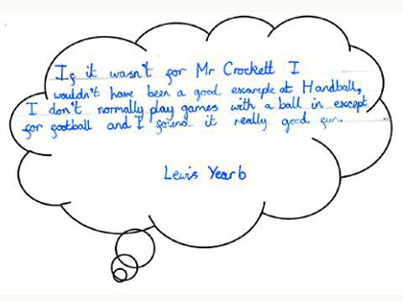
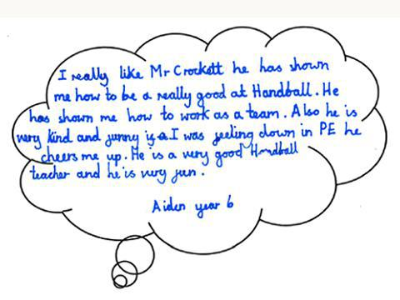
After school fencing club evaluation 04.12.14:
Attached are some of the photos from fencing club and again some children’s responses to taking part. We are really pleased to have had the opportunity to provide our children with a club we would otherwise have been unable to run.
We plan to continue using premier sport to coach in school for a whole day and provide us with 2 clubs. In the spring term premier sport will be coaching gymnastics to our FSU, year 3, year 4 and year 5 children. This will carried out as a team teach strategy to provide our staff with professional development and guidance.
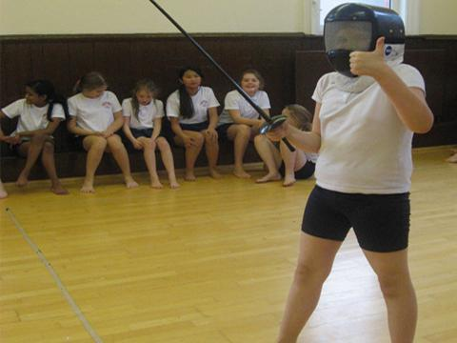
Primary Outreach Service Agreement
Start date: 08.09.14
Cost: £600
We have paid £600 to Richard Rose Central Academy to be part of their primary outreach service. For this money we receive 6 hours of coaching at the academy and 6 additional hours of staff development time.
Evaluation and impact completed on 04.12.14
Year 2 children have been to Richard Rose Central Academy to take part in a multi skills workshop for an afternoon. They were taught by young leaders from the academy and put many of their PE skills into practise.
Year 4 have also been to Richard Rose Central Academy to take part in a Tri-Golf workshop.
Y6 Trip to Fellside
Start Date:
Cost: £625
Our year 6 went to Fellside to complete a Victorian Christmas the activities included; a fell walk, role play – gentry servants, felt making, a visit to Goldscope mine and an educational walk around Caldbeck. They were able to complete some of the OAA objectives for year 6 Physical Education.
Evaluation and impact completed 04.12.14
Attached are some of the power point presentations that year 6 completed on return from fellside. It can clearly be seen that the experience had a huge impact on many of the skills taught through physical education. We will be funding this experience for year 6 children again in the future. Please watch Natasza’s Powerpoint video of our Fellside trip
Supply Cover for PE Event
Start Date: 24.03.14
Cost: £165
We spent £165 on supply cover so that our PE co-ordinator could attend the ‘New PE curriculum’ course.
Evaluation and Impact completed: 04.12.14
This course gave the PE co-ordinator information that was subsequently passed onto staff in staff meeting time. It up skilled our teachers and provided a new long term plan of objectives for our school.
Sporting Equipment/ clothing
Start Date: 04.04.14
Cost: £394
We have invested £394 in new equipment and sports wear for our school. We purchased new leotards for our gymnasts, new bibs for PE lessons and bought dance costumes for the Big Dance event.
Evaluation and Impact completed: 04.12.14
Leotards – we spent £257 on leotards for our year 1 and 2 gymnasts who took part in the key skills gymnastics competition for the first time and were placed 4th. The children loved competing against other schools and themselves.
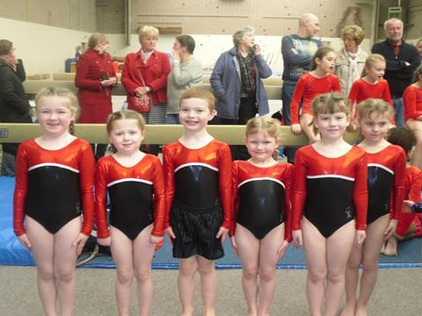
Big Dance – we bought black vest tops for the children who won best costume at the Big dance competition.
PE bibs – we have replaced our PE bibs which has impacted on the teaching of PE in school – making it easy to group children using bibs that are fit for purpose.
Football club coaching
Start date: April 2014- October 2014
Cost: £279
We have paid for an existing member of staff, Andrea Tate, to run football club for year 6 children after school.
Evaluation and Impact completed: 04.12.14
This has provided additional provision for 10 year 6 children to practise their football skills after school. It has increased participation in after school clubs and generated a lot of excitement about our school football team.
In September 2014 we increased our club numbers to 21 year 5 and 6 children and an extra member of existing staff, Lucy Wright, began jointly running the football club. This has had a huge impact on our sporting performance within the cluster and we are now 5th in the league table compared to 10th last year.
We are planning to use the sports funding to pay for Lucy Wright to continue running the club with Andrea Tate as we believe it is having a positive impact on our football teams results and attitude towards participating in cluster competitions.
Year 5 trip to Hawsend
Start Date: July 2013
Cost: £1136
Year 5 went to Hawsend to complete archery, orienteering and outdoor activities.
Evaluation completed 04.12.14:
Year 5 children were able to take part in whole day of outdoor provision that was financed by sports funding money. As we have limited grounds and no grass playing field we struggle to complete the OAA strand of PE. The sports funding money allowed the year 5 children to be taught by qualified instructors and gave them a fantastic day of OAA; helping them to achieve some objectives of the OAA strand.
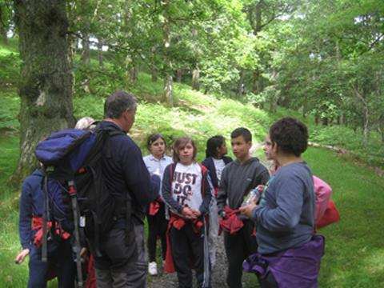
Year 6 Trip to Hawsend
Start date: July 2014
Cost £1036
Year 6 children were able to take part in a water sports activity day at Hawsend. Activities included canoeing…
Evaluation completed 04.12.14:
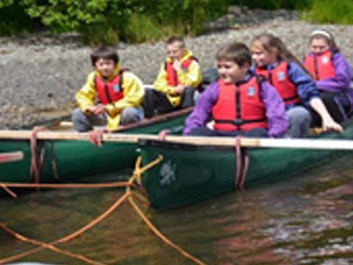
The sports funding money enabled us to provide year 6 with a full day of water sports activities we could not provide internally. The children were taught by qualified instructors and many experienced a day they would not usually experience

