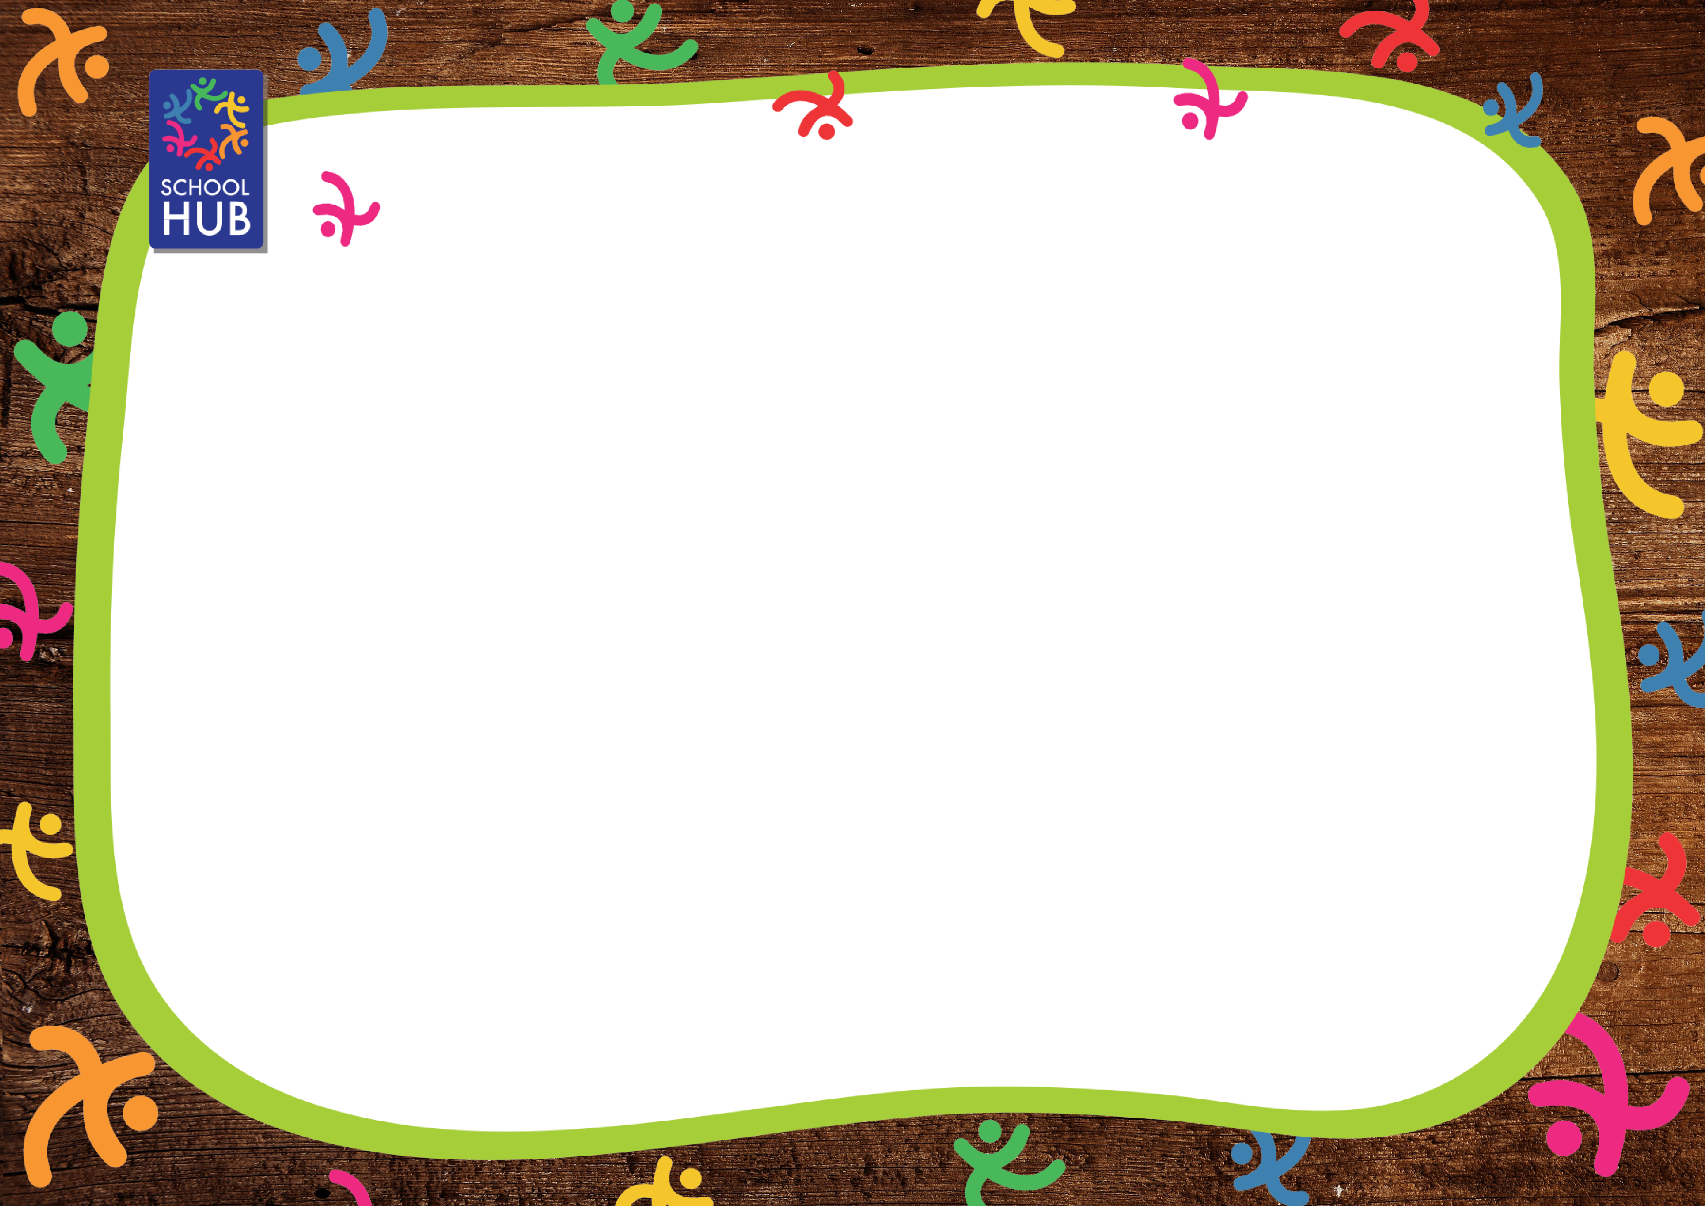
BROOK STREET PRIMARY WEEK ONE
CHOICE 1 |  | CHOICE 2 | CHOICE 3 | CHOICE 4 | SOMETHING SWEET
Monday | Cheese & Tomato Pizza  served with Herby Potatoes and Sweetcorn | Sweet Tomato Pasta  served with Garlic Bread and Sweetcorn | Jacket Potato  filled with Cheese, Tuna, Cheese & Beans or Beans served with Mixed Salad | Assorted Soft Rolls  filled with Ham, Cheese or Tuna served with Crinkle Cut Sea Salted Crisps and Mixed Salad | Vanilla Ice Cream Tub  or Fresh Yoghurt  or Fruit Salad
Tuesday | Choice of Cheeseburger or Beefburger in a Bun  served with Crispy Potato Wedges and Baked Beans | Veggie Nugget Burger in a Bun  served with Crispy Potato Wedges and Baked Beans | Jacket Potato  filled with Cheese, Tuna, Cheese & Beans or Beans served with Mixed Salad | Assorted Soft Rolls  filled with Ham, Cheese or Tuna served with Crinkle Cut Sea Salted Crisps and Mixed Salad | Chocolate Muffin  or Fresh Yoghurt  or Fruit Salad
Wednesday | Roast Chicken Breast  served with Yorkshire Pudding, Homemade Roast Potatoes, Broccoli & Carrot Medley and Gravy | Quorn Chicken Fillet  served with Yorkshire Pudding, Homemade Roast Potatoes, Broccoli & Carrot Medley and Gravy | Jacket Potato  filled with Cheese, Tuna, Cheese & Beans or Beans served with Mixed Salad | Assorted Soft Rolls  filled with Ham, Cheese or Tuna served with Crinkle Cut Sea Salted Crisps and Mixed Salad | Chocolate Brownie  or Fresh Yoghurt  or Fruit Salad
Thursday | Homemade Beef Pasta Bolognaise  served with Garlic Bread and Carrot & Sweetcorn Medley | Vegetarian Pasta Bolognaise  served with Garlic Bread and Carrot & Sweetcorn Medley | Jacket Potato  filled with Cheese, Tuna, Cheese & Beans or Beans served with Mixed Salad | Assorted Soft Rolls  filled with Ham, Cheese or Tuna served with Crinkle Cut Sea Salted Crisps and Mixed Salad | Homemade Shortbread  or Fresh Yoghurt  or Fruit Salad
Friday | Fish Fingers  served with Skinny Fries, Garden Peas and Tomato Ketchup | Vegetable Sausages  served with Skinny Fries, Garden Peas and Tomato Ketchup | Jacket Potato  filled with Cheese, Tuna, Cheese & Beans or Beans served with Mixed Salad | Assorted Soft Rolls  filled with Ham, Cheese or Tuna served with Crinkle Cut Sea Salted Crisps and Mixed Salad | Custard Cookie  or Fresh Yoghurt  or Fruit Salad

Available daily: Fresh Fruit, Salad and Bread Autumn/Winter 2026
If you have any questions about food allergens please speak to the kitchen team who will be happy to help.
Veg may change due to seasonality

BROOK STREET PRIMARY WEEK TWO
CHOICE 1 |  | CHOICE 2 | CHOICE 3 | CHOICE 4 | SOMETHING SWEET
Monday | Tomato & Mozzarella Pasta  served with Garlic Bread and Carrot, Cucumber and Cherry Tomato | Homemade Mac’n’Cheese  served with Garlic Bread and Carrot, Cucumber and Cherry Tomato | Jacket Potato  filled with Cheese, Tuna, Cheese & Beans or Beans served with Mixed Salad | Assorted Soft Rolls  filled with Ham, Cheese or Tuna served with Crinkle Cut Sea Salted Crisps and Mixed Salad | Strawberry Fruit Smoothie  or Fresh Yoghurt  or Fruit Salad
Tuesday | Sausage Roll  served with Herby Potatoes and Baked Beans | Vegetable Sausage  served with Herby Potatoes and Baked Beans | Jacket Potato  filled with Cheese, Tuna, Cheese & Beans or Beans served with Mixed Salad | Assorted Soft Rolls  filled with Ham, Cheese or Tuna served with Crinkle Cut Sea Salted Crisps and Mixed Salad | Banana Muffin  or Fresh Yoghurt  or Fruit Salad
Wednesday | Roast Beef  served with Yorkshire Pudding, Creamed Potato, Carrot & Sweetcorn Medley and Gravy | Cauliflower Cheese Yorkshire Pudding  served with Creamed Potato, Carrot & Sweetcorn Medley and Gravy | Jacket Potato  filled with Cheese, Tuna, Cheese & Beans or Beans served with Mixed Salad | Assorted Soft Rolls  filled with Ham, Cheese or Tuna served with Crinkle Cut Sea Salted Crisps and Mixed Salad | Chocolate Cookie  or Fresh Yoghurt  or Fruit Salad
Thursday | Chicken Korma  served with Rice and Sweetcorn | Vegetarian Korma  served with Rice and Sweetcorn | Jacket Potato  filled with Cheese, Tuna, Cheese & Beans or Beans served with Mixed Salad | Assorted Soft Rolls  filled with Ham, Cheese or Tuna served with Crinkle Cut Sea Salted Crisps and Mixed Salad | Iced Sponge Cake  or Fresh Yoghurt  or Fruit Salad
Friday | Breaded Fish Fillet  served with Skinny Fries, Mushy Peas and Tomato Ketchup | Breaded Salmon Goujons  served with Skinny Fries, Mushy Peas and Tomato Ketchup | Jacket Potato  filled with Cheese, Tuna, Cheese & Beans or Beans served with Mixed Salad | Assorted Soft Rolls  filled with Ham, Cheese or Tuna served with Crinkle Cut Sea Salted Crisps and Mixed Salad | Raspberry Jelly  or Fresh Yoghurt  or Fruit Salad

Available daily: Fresh Fruit, Salad and Bread Autumn/Winter 2026
If you have any questions about food allergens please speak to the kitchen team who will be happy to help.
Veg may change due to seasonality

BROOK STREET PRIMARY WEEK THREE
CHOICE 1 |  | CHOICE 2 | CHOICE 3 | CHOICE 4 | SOMETHING SWEET
Monday | Spaghetti Pork Meatballs in Homemade Tomato Sauce  served with Garlic Bread and Broccoli & Garden Pea Medley | Veggie Pizza Slice  served with Herby Potatoes and Broccoli & Garden Pea Medley | Jacket Potato  filled with Cheese, Tuna, Cheese & Beans or Beans served with Mixed Salad | Assorted Soft Rolls  filled with Ham, Cheese or Tuna served with Crinkle Cut Sea Salted Crisps and Mixed Salad | Strawberry Ice Cream Roll  or Fresh Yoghurt  or Fruit Salad
Tuesday | Pork Sausages  served with Creamed Potato and Baked Beans | Vegetable Sausages  served with Creamed Potato and Baked Beans | Jacket Potato  filled with Cheese, Tuna, Cheese & Beans or Beans served with Mixed Salad | Assorted Soft Rolls  filled with Ham, Cheese or Tuna served with Crinkle Cut Sea Salted Crisps and Mixed Salad | Melted Moments Biscuit  or Fresh Yoghurt  or Fruit Salad
Wednesday | Roast Chicken Breast  served with Yorkshire Pudding, Homemade Roast Potatoes, Carrot & Sweetcorn Medley and Gravy | Quorn Chicken Fillet  served with Yorkshire Pudding, Homemade Roast Potatoes, Carrot & Sweetcorn Medley and Gravy | Jacket Potato  filled with Cheese, Tuna, Cheese & Beans or Beans served with Mixed Salad | Assorted Soft Rolls  filled with Ham, Cheese or Tuna served with Crinkle Cut Sea Salted Crisps and Mixed Salad | Flapjack  or Fresh Yoghurt  or Fruit Salad
Thursday | Ham & Cheese Pizza Naan  served with Herby Potatoes and Veg Crudites | Cheese & Tomato Pizza Naan  served with Herby Potatoes and Veg Crudites | Jacket Potato  filled with Cheese, Tuna, Cheese & Beans or Beans served with Mixed Salad | Assorted Soft Rolls  filled with Ham, Cheese or Tuna served with Crinkle Cut Sea Salted Crisps and Mixed Salad | Homemade Lemon Drizzle Cake  or Fresh Yoghurt  or Fruit Salad
Friday | Fish Fingers  served with Skinny Fries and Baked Beans | Sweet Tomato Pasta  served with Garlic Bread and Garden Peas | Jacket Potato  filled with Cheese, Tuna, Cheese & Beans or Beans served with Mixed Salad | Assorted Soft Rolls  filled with Ham, Cheese or Tuna served with Crinkle Cut Sea Salted Crisps and Mixed Salad | Belgian Waffle and Cream  or Fresh Yoghurt  or Fruit Salad

Available daily: Fresh Fruit, Salad and Bread Autumn/Winter 2026
If you have any questions about food allergens please speak to the kitchen team who will be happy to help.
Veg may change due to seasonality

