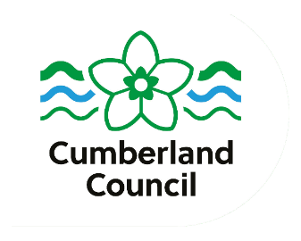
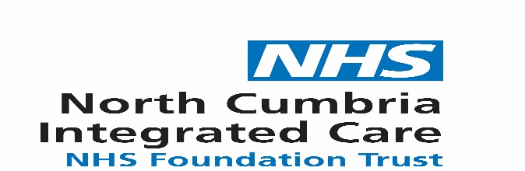
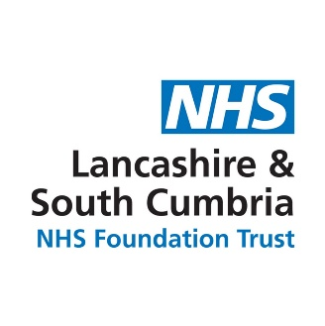



iii
This drop in is for parents and carers of:
- Children who have been seen by the Community Paediatrician.
- Children who are on the ‘multi agency assessment team’ (MAAT) pathway.
- Children who are awaiting the outcome of their assessment.
- Children and siblings are welcome!

Children and siblings welcome!

Are you exploring an autism assessment for your child?
Do you have any questions?
Would you like support, advice and signposting?

Come and meet us and other families at the library in your area…
- Autism pathway navigator
- Speech and Language Therapist
- Occupational Therapist
- Health Visitor
- Other carers

East Cumbria dates:
Thursday 7th November
1-3pm at Carlisle Library.

West Cumbria dates:
Date for December TBC
at Workington Library.
Whitehaven Family Hub:
Friday 18th October 1-3pm
For further details, you can contact our Autism Pathway Navigator NorthCumbriaChildrensMAAT@ncic.nhs.uk

Uuu

